TULARE 2016/17 CAPER

Consolidated Annual Performance and Evaluation Report (CAPER)

Final 06.30.17

Approved 10/17/17



## CR-05 - Goals and Outcomes

**Progress the jurisdiction has made in carrying out its strategic plan and its action plan. 91.520(a)**

This could be an overview that includes major initiatives and highlights that were proposed and executed throughout the program year.

This 2016/17 Consolidated Annual Performance and Evaluation Report (CAPER) is the City of Tulare's annual report to the U.S. Department of Housing and Urban Development (HUD) describing the use of federal Community Development Block Grant (CDBG) funds during the second program year of the 2015-2019 Consolidated Plan period covering July 1, 2016 thorugh June 30, 2017.

This section addresses activities undertaken during the PY 2016/17 to address pertinent Consolidated Plan and Action Plan objectives and areas of high priority. To meet the City of Tulare's goals and abjectives for PY16, the City allocated funding to projects which: Supported public service activities; Improved quality and availability of public facilities; and efforts which provide services for the homeless.

For the 2016/17 program year, the City received $605,409 in CDBG funds and $76,735 in program income. Carryover funds of $809,536, from prior year rollover, in addition to the current program year award,  the City has available funds for the PY16 year totaling $1,491,680. Together with other federal, state and local investments (i.e. State HOME funds), HUD resources allowed the City and it community partners to provide services to accomplish goals and objectives determined by the 2015-2019 Consolidated Plan.

**Comparison of the proposed versus actual outcomes for each outcome measure submitted with the consolidated plan and explain, if applicable, why progress was not made toward meeting goals and objectives. 91.520(g)**

Categories, priority levels, funding sources and amounts, outcomes/objectives, goal outcome indicators, units of measure, targets, actual outcomes/outputs, and percentage completed for each of the grantee’s program year goals.

|  |  |  |  |  |  |  |  |  |  |  |
| --- | --- | --- | --- | --- | --- | --- | --- | --- | --- | --- |
| **Goal** | **Category** | **Source / Amount** | **Indicator** | **Unit of Measure** | **Expected – Strategic Plan** | **Actual – Strategic Plan** | **Percent Complete** | **Expected – Program Year** | **Actual – Program Year** | **Percent Complete** |
|  |  |  |  |  |  |  |  |  |  |  |

Table 1 - Accomplishments – Program Year & Strategic Plan to Date

**Assess how the jurisdiction’s use of funds, particularly CDBG, addresses the priorities and specific objectives identified in the plan, giving special attention to the highest priority activities identified.**

**\*Note: IDIS Table 1 Accomplishments did not populate. See Attachment 1 Table 1 and Figure 1 and 2 for accomplishment detail.**

**Public Service Activities**:

The maximum Public Service funding available for PY 2016/17 was $98,790. The City's PY 2016/17 Annual Action Plan allocated  $84,300 to public service activities.

Public service completed consisted of:

* Graffiti cleanup services in West Tulare area; (1,152 graffiti cleanup incidents utilizing CDBG)
* The Kings Tulare Homeless Alloance Project Homeless Connect and Point in Time Survey; (total served - 885; 121 in Tulare)
* The SPC/SNAP Case Management program supports the administration of HUD rental assistance program for homeless with special needs. This program provides rental assistance housing vouchers for Tulare residents.
* Community Service Employment Training (CSET) had a change in funding request from #LEAD youth program to Homeless Vet Road to Independence (RTI) program. The RTI program assisted 6 homeless veteran families with household necessary items with beds and basic furniture.

**Public Improvement Activities:**

PY 2016/17 identified two public facility improvements projects to be completed utilizing the City's CDBG funding for which $415,000 was allocated.

* Final phase of sewer and plumbing repairs at a transitional housing facility for families who are victims of domestic violence.
* Begin the design of public infrastructure improvements on E Street consisting of water and sewer upgrades, street improvements and ADA upgrades.

**Housing Activities**:

Although no specific housing activities were planned in the PY 2016/17, the City was able to utilize State HOME funding to assist three families with First Time Homebuyers loans.

## CR-10 - Racial and Ethnic composition of families assisted

**Describe the families assisted (including the racial and ethnic status of families assisted). 91.520(a)**

**Table 2 – Table of assistance to racial and ethnic populations by source of funds**

**Narrative**

The numbers in Table 2 did not populate in IDIS. See Attachment 1 Table 2 to reflect the homeless persons assisted during the Point in Time homeless assessment held January 26, 2017 by Kings Tulare Homeless Alliance.

## CR-15 - Resources and Investments 91.520(a)

**Identify the resources made available**

|  |  |  |  |
| --- | --- | --- | --- |
| **Source of Funds** | **Source** | **Resources Made Available** | **Amount Expended During Program Year** |
| CDBG | CDBG | 1,491,680 | 125,977 |
| HOME | HOME |  |  |
| HOPWA | HOPWA |  |  |
| ESG | ESG |  |  |
| Other | Other |  |  |

Table 3 - Resources Made Available

**Narrative**

HOME funds are allocated through the State. In 2016/17 HOME grant and program income available was $461,266, of which $228,328 was expended. The 2013 HOME grant ended January 31, 2017 and was able to accomplish 3 First Time Home Buyer loans this year for a total of 15 during the program period.

SPC/SNAP funding is currently continuing with HUD CoC funding. In 2016/17 available funds were $133,890 of which $107,449 was expended. This program has been in place since 2009 and provides rental assistance and supportive services to very low income persons. This program is supported by City's of Tulare, Visalia, and Porterville.

**Identify the geographic distribution and location of investments**

|  |  |  |  |
| --- | --- | --- | --- |
| **Target Area** | **Planned Percentage of Allocation** | **Actual Percentage of Allocation** | **Narrative Description** |
| Citywide | 100 | 100 | Funds will be available citywide |

Table 4 – Identify the geographic distribution and location of investments

**Narrative**

The designated community asssitance for all priorities is Citywide for low to moderate-income families.

**Leveraging**

**Explain how federal funds leveraged additional resources (private, state and local funds), including a description of how matching requirements were satisfied, as well as how any publicly owned land or property located within the jurisdiction that were used to address the needs identified in the plan.**

All applicants for CDBG funds are strongly encouraged to leverage their CDBG request with other funding sources. This is a factor used when making funding recommendations to the City Council. The City supports applications by other entitles for additional federal resources for proposed projects or programs as long as they are consistent with the City's policies, ordinances, and Strategic Plan.

CDBG Public Owned Land/Property:

175-175-008 111 W Kern Ave - Lighthouse Rescue Mission is a Women's Shelter - homeless housing facility that was purchased in April 2005.

## CR-20 - Affordable Housing 91.520(b)

**Evaluation of the jurisdiction's progress in providing affordable housing, including the number and types of families served, the number of extremely low-income, low-income, moderate-income, and middle-income persons served.**

|  | One-Year Goal | Actual |
| --- | --- | --- |
| Number of Homeless households to be provided affordable housing units | 0 | 0 |
| Number of Non-Homeless households to be provided affordable housing units | 0 | 0 |
| Number of Special-Needs households to be provided affordable housing units | 0 | 0 |
| **Total** | **0** | **0** |

Table 5 – Number of Households

|  | One-Year Goal | Actual |
| --- | --- | --- |
| Number of households supported through Rental Assistance | 0 | 0 |
| Number of households supported through The Production of New Units | 0 | 0 |
| Number of households supported through Rehab of Existing Units | 0 | 0 |
| Number of households supported through Acquisition of Existing Units | 0 | 0 |
| **Total** | **0** | **0** |

Table 6 – Number of Households Supported

**Discuss the difference between goals and outcomes and problems encountered in meeting these goals.**

The City identifies affordable hosuing as a goal in the 2015-2019 Consolidated Plan. For the last two program years, the City was not able to devote CDBG resources to meet this goal. The Community Development Department was able to hire a full time Housing and Grants Specialist in October 2016, and a housing program is expected to be established in 2017/18.

**Discuss how these outcomes will impact future annual action plans.**

Action plan 2017/18 has been developed to allocate funding for housing development and renovation and expected to have community development organizations administer the programs. Available programs will depend on the availability of funding and city council direction. the City will continue to apply for State HOME finding as funds become available.

**Include the number of extremely low-income, low-income, and moderate-income persons served by each activity where information on income by family size is required to determine the eligibility of the activity.**

Table 7 – Number of Households Served

**Narrative Information**

## CR-25 - Homeless and Other Special Needs 91.220(d, e); 91.320(d, e); 91.520(c)

**Evaluate the jurisdiction’s progress in meeting its specific objectives for reducing and ending homelessness through:**

**Reaching out to homeless persons (especially unsheltered persons) and assessing their individual needs**

CoC completed their annual Point in Time (PIT) and Project Homeless Connect (PHC) outreach to the homeless on January 26, 2017. The PIT count detail for Tulare indicated that 84% of mostly single people are sleeping in places not meant for humans. The City will continue to collaborate with the CoC and the community as a whole to address these issues.

**Addressing the emergency shelter and transitional housing needs of homeless persons**

The City of tulare continues to be the lead on Shelter Plus Care (SPC) and Special Needs Assistance Program (SNAP) grant funding by HUD to provide housing units for homeless people with special needs. Family Services for Tulare COunty (FSTC) manages the program. Tulare Housing First Programs are currently providing eight transitional housing rental assistance.

**Helping low-income individuals and families avoid becoming homeless, especially extremely low-income individuals and families and those who are: likely to become homeless after being discharged from publicly funded institutions and systems of care (such as health care facilities, mental health facilities, foster care and other youth facilities, and corrections programs and institutions); and, receiving assistance from public or private agencies that address housing, health, social services, employment, education, or youth needs**

The City will continue to reach out to organizations, such as Lighthouse Rescue Mission and CoC to establish the scope of need for these individuals and establish a plan to assist.

**Helping homeless persons (especially chronically homeless individuals and families, families with children, veterans and their families, and unaccompanied youth) make the transition to permanent housing and independent living, including shortening the period of time that individuals and families experience homelessness, facilitating access for homeless individuals and families to affordable housing units, and preventing individuals and families who were recently homeless from becoming homeless again**

The non-profit and faith-based communtiy play a key role in the current CoC system. Several agencies throughout the County provide programs ranging from feeding the homeless on the street to creating permanent supporting housing opportunities. these services are available to homeless families with children, and single men and women.

## CR-30 - Public Housing 91.220(h); 91.320(j)

**Actions taken to address the needs of public housing**

The Housing Authority of Tulare County (HATC) provides rental assistance to very low to and moderate-income families, seniors, and special need individuals throughout Tulare County. HATC offers many different programs, including the conventional public housing programs, the housing choice voucher program, the farm labor program for families with farm labor income, senior housing programs, and other housing programs. They also own and manage some individual subsidized rental complexes that do not fall under the previous categories.

HATC properties owned and managed in Tulare are Country Manor, West Trail, Cypress Cove, and Aspen Court. The exact number of units and familieis are unknown at the time of this report, but the City will reach out to them and find out, as well as find out what the immediate need is and if CDBG funds can be utilized.

**Actions taken to encourage public housing residents to become more involved in management and participate in homeownership**

The City will be expanding its community outreach through social media, workshops and group presentations in upcoming program years.

**Actions taken to provide assistance to troubled PHAs**

HATC is a high preforming PHA and not determined to be troubled.

## CR-35 - Other Actions 91.220(j)-(k); 91.320(i)-(j)

**Actions taken to remove or ameliorate the negative effects of public policies that serve as barriers to affordable housing such as land use controls, tax policies affecting land, zoning ordinances, building codes, fees and charges, growth limitations, and policies affecting the return on residential investment. 91.220 (j); 91.320 (i)**

In the development of the 2015-2023 Housing Element, the City evaluated significant public policies effecting affordable housing development such as land use controls, tax policies affecting land, zoning ordinances, building codes, fee and charges and growth limitations. Based on this evaluation, the City determined that it has taken steps to ameliorate the negative efforts of public policies that may have been a barrier to affordable housing.

The two primary barriers to affordable housing identified in the 2015-2019 Consolidated Plan include housing affordability and the lack of monetary resources necessary to develop and sustain affordable housing. The barriers are related in the sense that demand for affordable housing exceeds the supply and insufficient resources are available to increase the supply of affordable housing to meet demand.

The City actively monitors its existing zoning and development standards to ensure the necessiity and efficacy for achieving the goal of safe and livable housing for all income catergories. In 2016, the City amended it municipal code to add provisions for density bonus for high-density projects.

**Actions taken to address obstacles to meeting underserved needs. 91.220(k); 91.320(j)**

The primary obstacles to meet the underserved needs of low and moderate-income people include lack of funding from federal, state and other local sources, the high cost of housing that is not affordable to low income people and the lack of availability of home improvement financing in the private lending industry. The City is committed into utilizing all available funding sources and organizations to address these issues.

**Actions taken to reduce lead-based paint hazards. 91.220(k); 91.320(j)**

The residential Lead Based Paint Hazard Reduction Act of 1992 (Title X) emphasizes prevention of childhood lead poisoning through housing-based approaches. To reduce lead-based paint hazards, the City conduct lead-based paint testing and risk assessments for each property assisted that was built prior to January 1, 1978 and will incorporate safe work practices or abatement into the scope of work as required to reduce lead based paint hazards in accordance with 24 CFR Park 35.

**Actions taken to reduce the number of poverty-level families. 91.220(k); 91.320(j)**

The implementation of CDBG activities meeting the goals established in the 2015-2019 Consolidated Plan – Strategic Plan will help to reduce the number of poverty-level families by:

* Supporting activities that expand the supply of housing that is affordable to low- and moderate-income households;
* Supporting activities that preserve the supply of decent housing that is affordable to low- and moderate-income households;
* Supporting a continuum of housing and public service programs to prevent and eliminate homelessness;
* Supporting housing preservation programs that assure low income households had a safe, decent and appropriate place to live;
* Support public services for low- and moderate-income residents including those with special needs and those at-risk of homelessness; and
* Promoting economic opportunity for low- and moderate-income residents

In addition to these local efforts, mainstream state and federal resources also contribute to reducing the number of individuals and families in poverty.  Federal programs such as the Earned Income Tax Credit and Head Start provide pathways out of poverty for families who are ready to pursue employment and educational opportunities.  Additionally in California, the primary programs that assist families in poverty are CalWORKs, Cal Fresh (formerly food stamps) and Medi-Cal.  Together, these programs provide individuals and families with employment assistance, subsidy for food, medical care, childcare and cash payments to meet basic need such as housing, nutrition and transportation.  Other services are available to assist persons suffering from substance abuse, domestic violence and mental illness.

**Actions taken to develop institutional structure. 91.220(k); 91.320(j)**

The institutional delivery system for Tulare can be developed to be a high-functioning and collaborative relationship between local government and the nonprofit sector comprised of a network of capable non-profit organizations that are delivering a full range of services to residents.  Strong City departments will anchor the administration of HUD programs and the housing, community and economic development activities that are implemented by the City to support and enhance the existing institutional structure. The City of Tulare will collaborate with affordable housing developers and non-profit agencies through the 2016-17 Annual Action Plan to ensure that the needs of low- and moderate-income residents are met as envisioned with the 2015-2019 Consolidated Plan – Strategic Plan.

**Actions taken to enhance coordination between public and private housing and social service agencies. 91.220(k); 91.320(j)**

To enhance coordination between public and private housing and social service agencies, the City will continue consulting with and inviting the participation of a wide variety of agencies and organizations involved in the delivery of housing and supportive services to low- and moderate-income residents in Tulare.

**Identify actions taken to overcome the effects of any impediments identified in the jurisdictions analysis of impediments to fair housing choice. 91.520(a)**

The City of Tulare acknowledges that it is required to conduct an Analysis of Impediments (AI) to Fair Housing Choice as a condition of accepting Community Development Block Grant funding. The City will take appropriate actions to overcome the effects of impediments identified through the analysis, and maintain records reflecting the analysis and actions taken in this regard.

In order to assist in meeting these broad objectives, the City of Tulare will do the following:

* Analyze and support the elimination of housing discrimination in the City of Tulare
* Promote fair housing choice for all persons
* Provide opportunities for inclusive patterns of housing occupancy regardless of race, color, religion, sex, familial status, disability, and national origin
* Promote housing that is structurally accessible to, and usable by, all persons, particularly persons with disabilities, and
* Foster compliance with the nondiscrimination provisions of the Fair Housing Act.

 The City of Tulare adheres to Fair Housing Compliance in a Coordinated Assessment System by conducting the following activities:

Affirmatively market housing and supportive services to eligible persons regardless of race, color, national origin, religion, sex, age, familial status, or handicap who are least likely to apply in the absence of special outreach, and maintain records of those marketing activities;

Where the City encounters a condition or action that impedes fair housing choice for current or prospective program participants, the City will take action consistent with certification of its Consolidated Plan; and

Provide program participants with information on rights and remedies available under applicable federal, state, and local fair housing and civil rights laws.

## CR-40 - Monitoring 91.220 and 91.230

**Describe the standards and procedures used to monitor activities carried out in furtherance of the plan and used to ensure long-term compliance with requirements of the programs involved, including minority business outreach and the comprehensive planning requirements**

To ensure that CDBG funds are used efficiently and in compliance with applicable regulations, the City will provide technical assistance to all subrecipients at the beginning of each program year and monitor subrecipients throughout the program year. The Subrecipient agreement will contain a monitoring schedule and regular periodic claims and reported process.  If the Subrecipient is struggling, then this will allow the City to assist.  Program monitoring and compliance will be put in place to comply with CDBG program regulations.

The City will be proactive in minority business outreach and development to promote economic business opportunities for low- and moderate-income residents through a partnership with the Tulare Chamber of Commerce.

**Technical Assistance**

To enhance compliance with federal program regulations, the City will provide an annual Notice of Funding Availability (NOFA) workshop to review the Plan goals, program requirements and available resources with potential applicants.  Subsequent to the approval of the Annual Action Plan, a mandatory Subrecipient workshop is held to review program regulations in detail, to provide useful forms and resources for documenting compliance and to review the City’s compliance procedures and requirements.  Additionally, individualized technical assistance is provided on an as-needed basis throughout a program year.

**Activity Monitoring**

All activities will be monitored, beginning with a detailed review upon receipt of an application consolidated to determine eligibility, conformance with a National Objective and conformance with a Plan goal. This review will examine the proposed use of funds, eligibility of the service area, eligibility of the intended beneficiaries and likelihood of compliance with other federal requirements such as the National Environmental Policy Act, the System for Award Management (SAM), debarment list, prevailing wage, Minority and Women Business Enterprise, Section 3 and federal acquisition and relocation regulations, as applicable.

**Citizen Participation Plan 91.105(d); 91.115(d)**

**Describe the efforts to provide citizens with reasonable notice and an opportunity to comment on performance reports**.

The City has adopted a Citizen Participation Plan (CPP) with the 2015-2019 Consolidated Plan to ensure that all citizens of Tulare, units of local government, housing agencies and other interested parties are provided with the opportunity to participate in the planning and reporting process. The draft CAPER was made available on the City website on August 23, 2017 and September 27, 2017 and at the following locations:

**City Hall:  Community Development Department**411 E Kern Ave Tulare, CA  93274

**Tulare Public Library – Reference Desk**491 North M Street Tulare, California 93274

**Tulare Senior Center – Reference Desk**201 North F Street Tulare, California 93274

**Community Workshop held on September 5, 2017 at: Tulare Public Library**491 North M Street Tulare, California 93274

Additional public review period was noticed as part of Citizen Participation Plan for period September 27, 2017 through October 16, 2017.

A revised public hearing will be conducted before the City Council on Tuesday, October 17, 2017 to solicit final comments from residents and interest parties.  A summary of any written or oral comments received during the public hearing is included in appendix B.

**CR-45 - CDBG 91.520(c)**

**Specify the nature of, and reasons for, any changes in the jurisdiction’s program objectives and indications of how the jurisdiction would change its programs as a result of its experiences.**

The City is committed to making a significant impact on strategies to address the high priority needed established in the 2015-2019 Consolidated Plan – Strategic Plan:

* Support Public Services Activities
* Improve Quality and Availability of Public Facilities
* Fund Efforts to Provide for Homelessness
* Assist With Development or Renovation of Housing
* Support Economic Development Efforts

The City will establish programs to support these objectives with the assistance of other city departments, community outreach and participation, non-profit organizations, program participants, and other interested parties. Should any challenges arise in the implementation of CDBG funded activities; the City will proactively identify additional opportunities to invest CDBG funds to meet Strategic Plan goals.

**Does this Jurisdiction have any open Brownfields Economic Development Initiative (BEDI) grants?**

No

**[BEDI grantees] Describe accomplishments and program outcomes during the last year.**

**Attachment**

**Attachment 1**

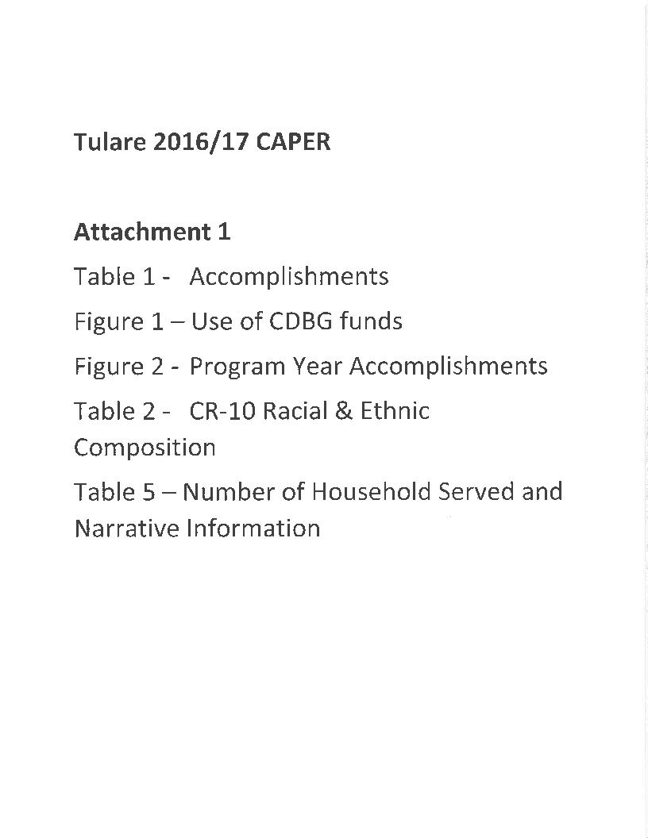

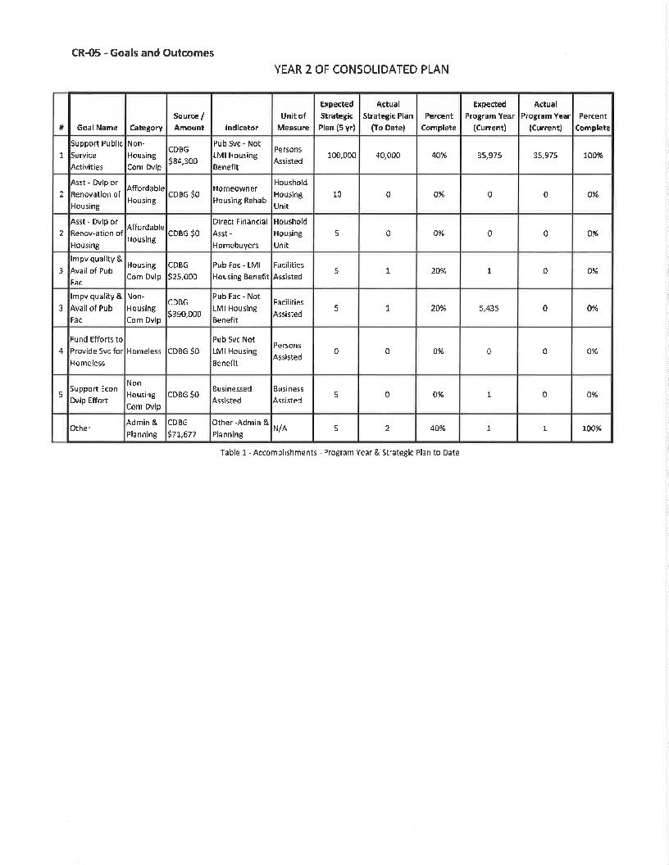

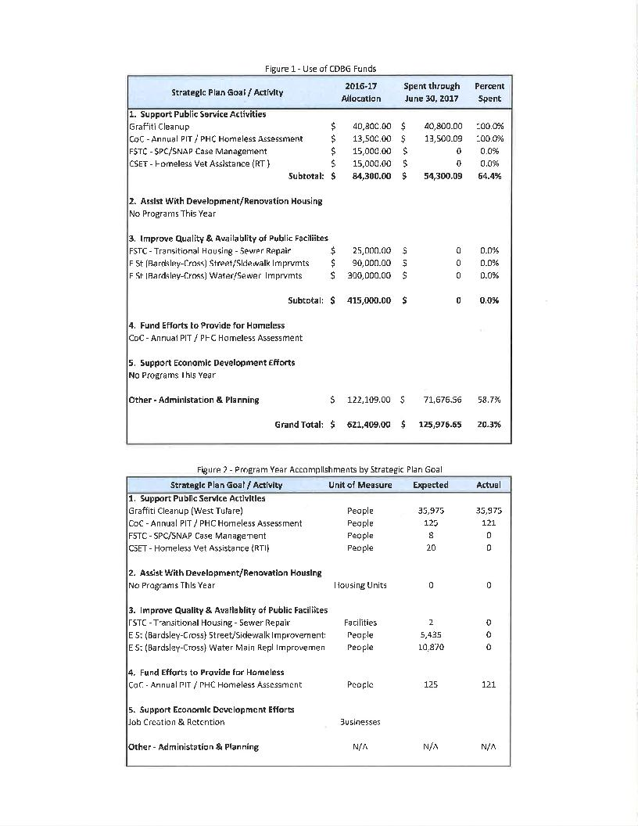

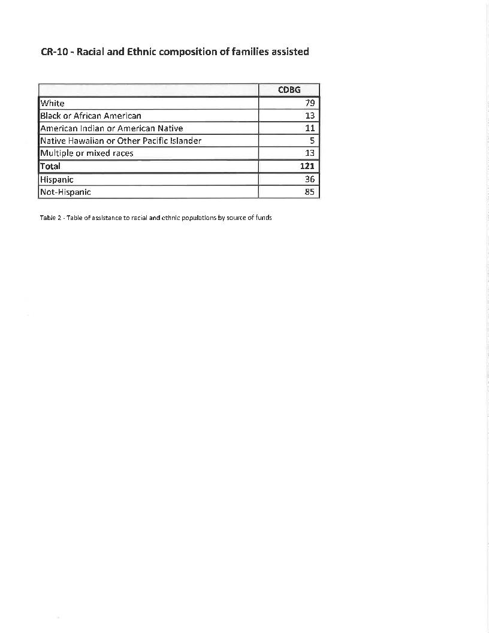

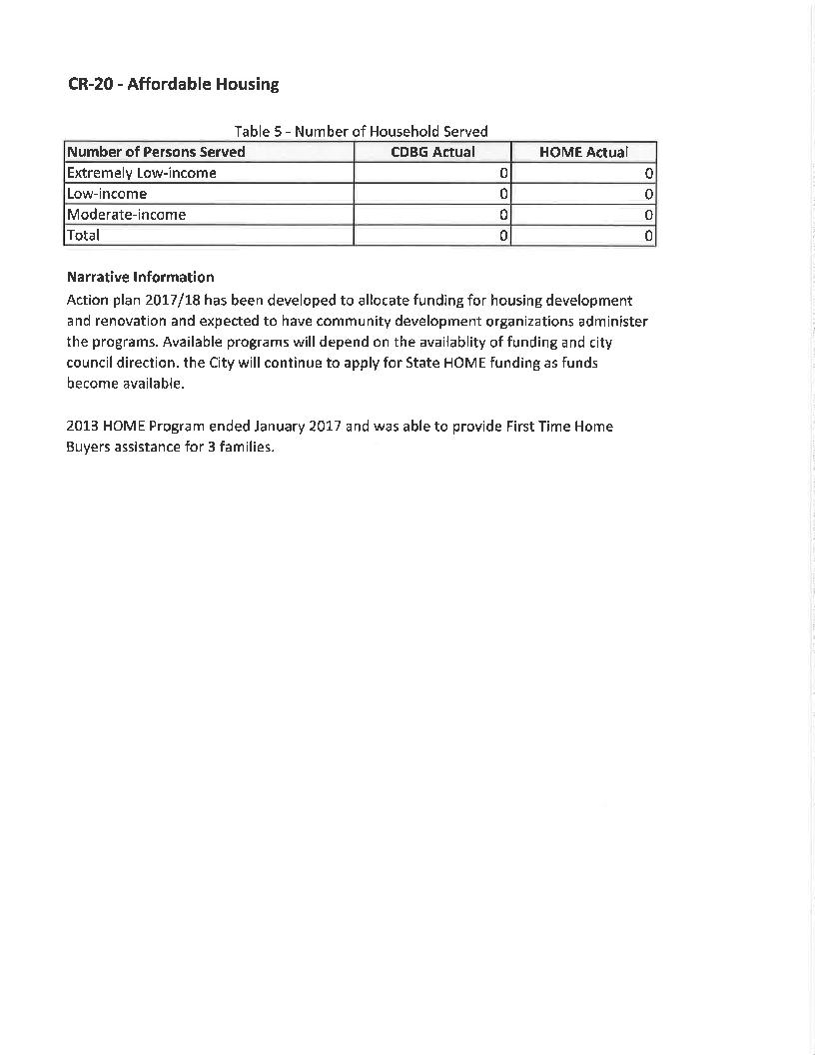

**Appendix A Public Notice**



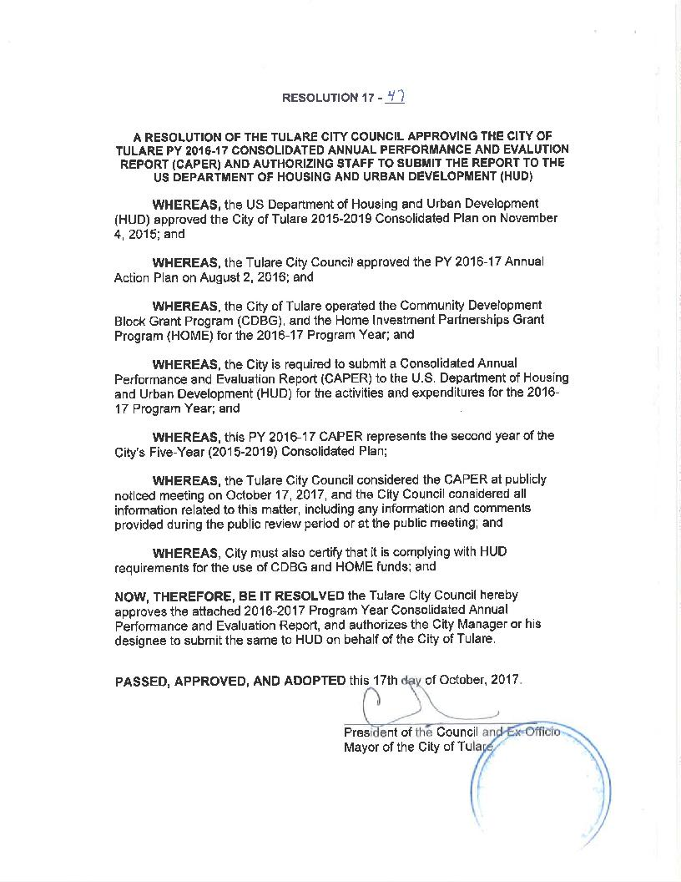

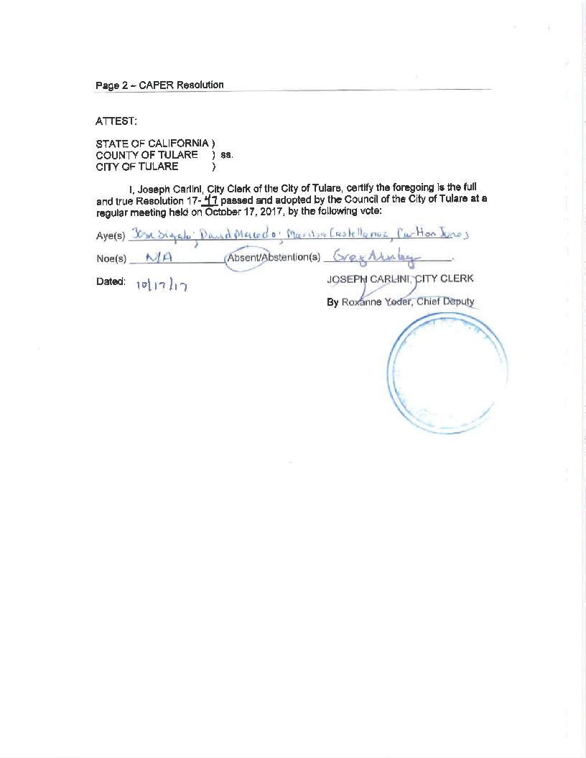

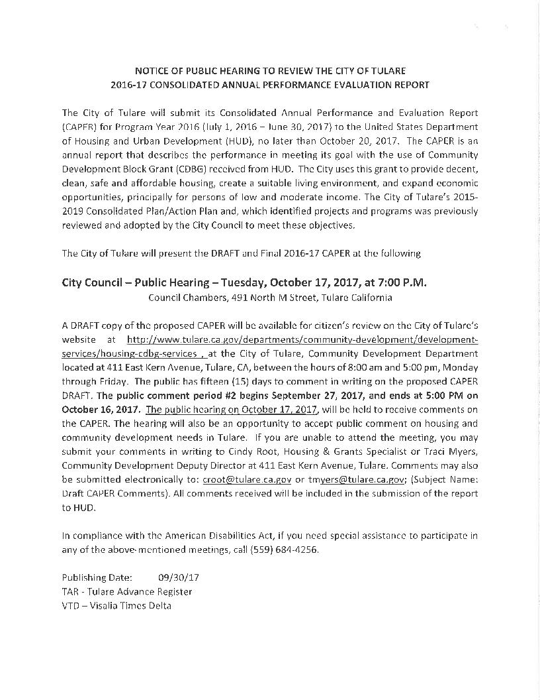

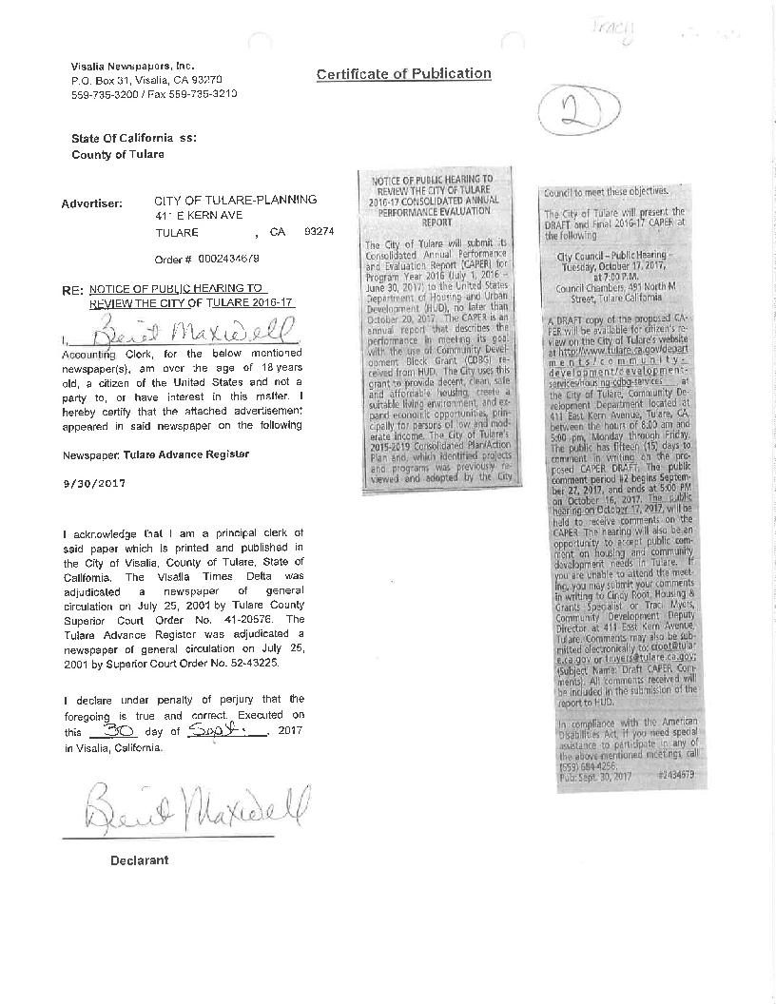

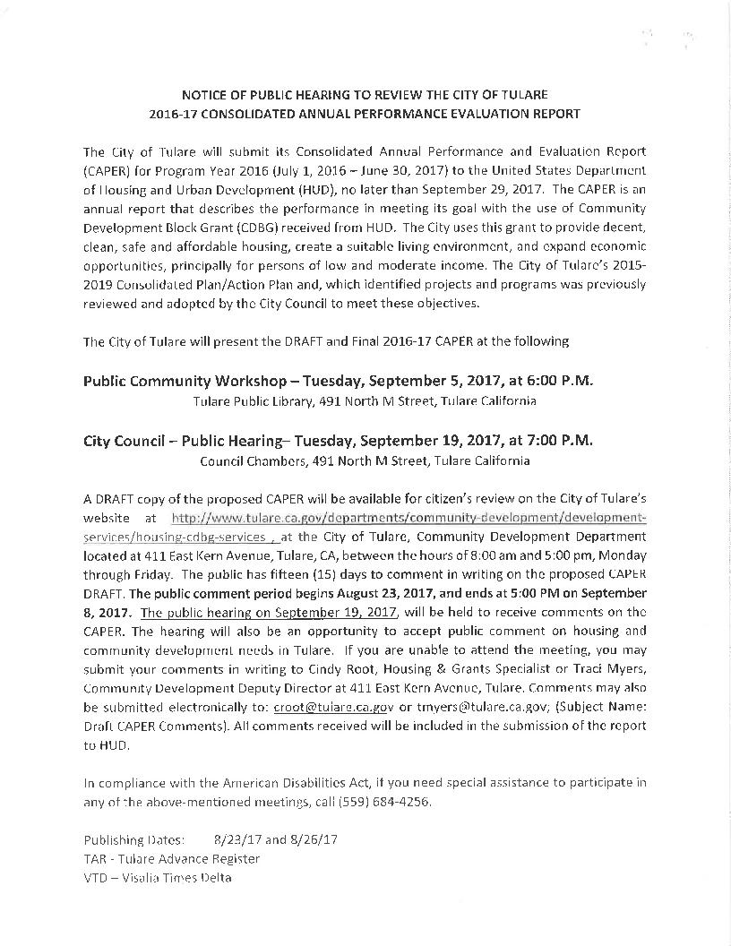

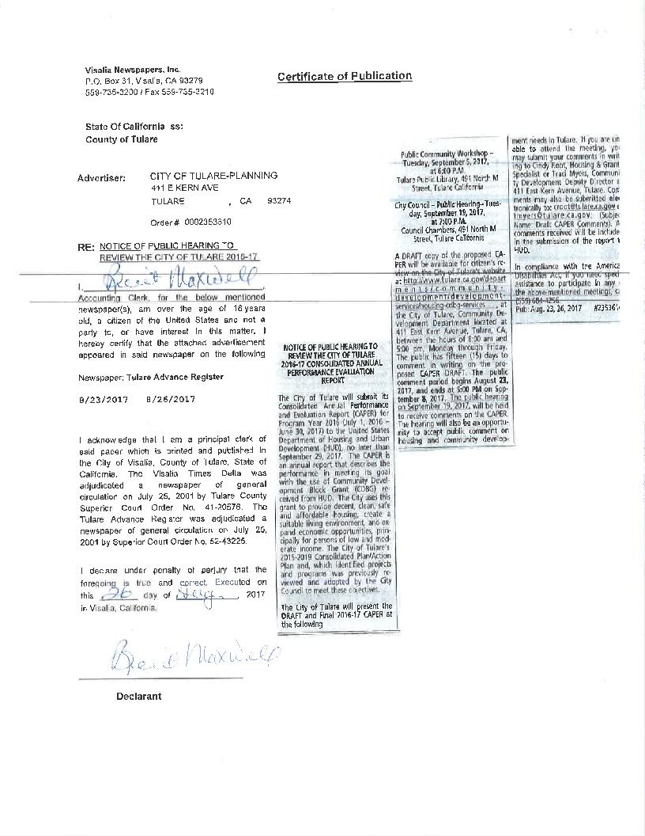

**Appendix B Citizen Participation**

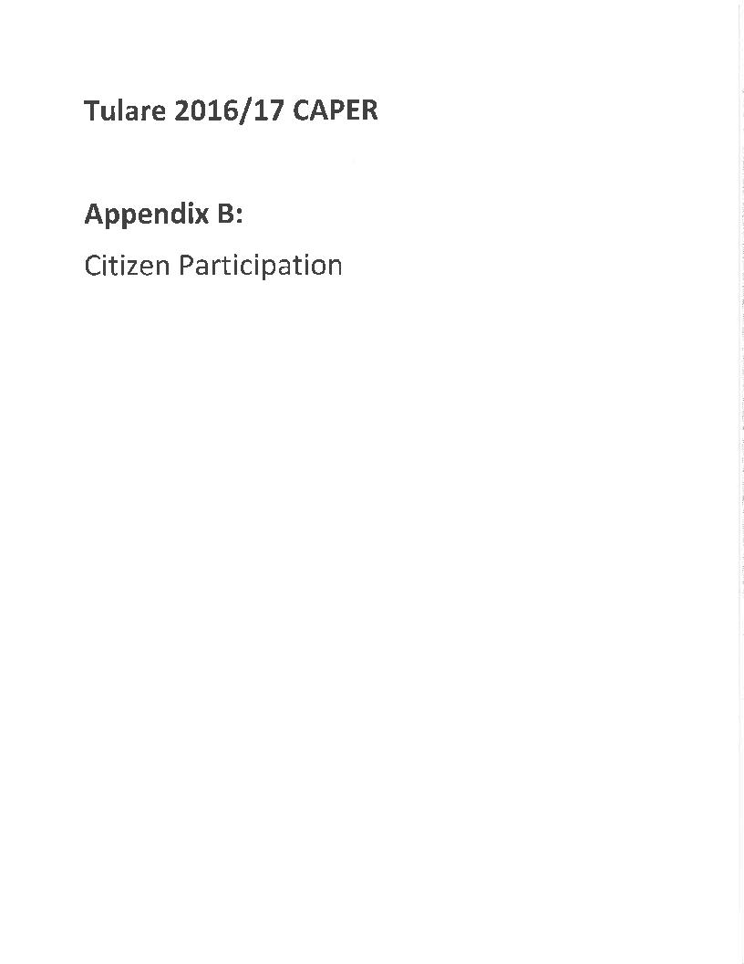

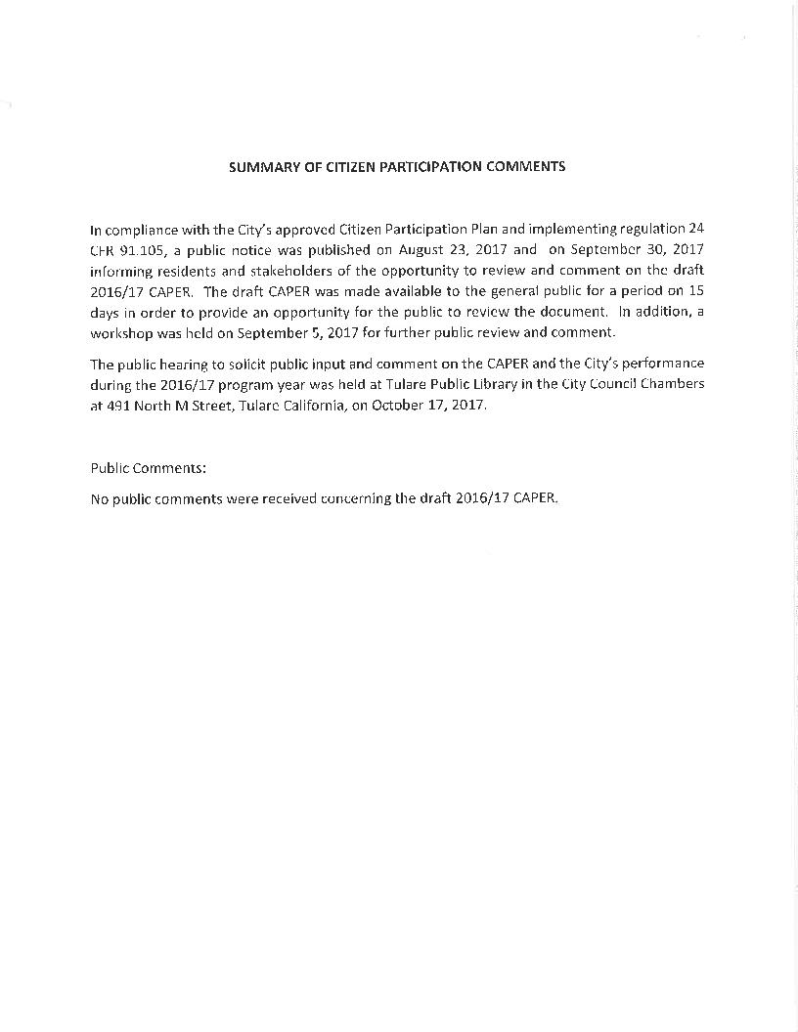

**Appendix C City Map Census**

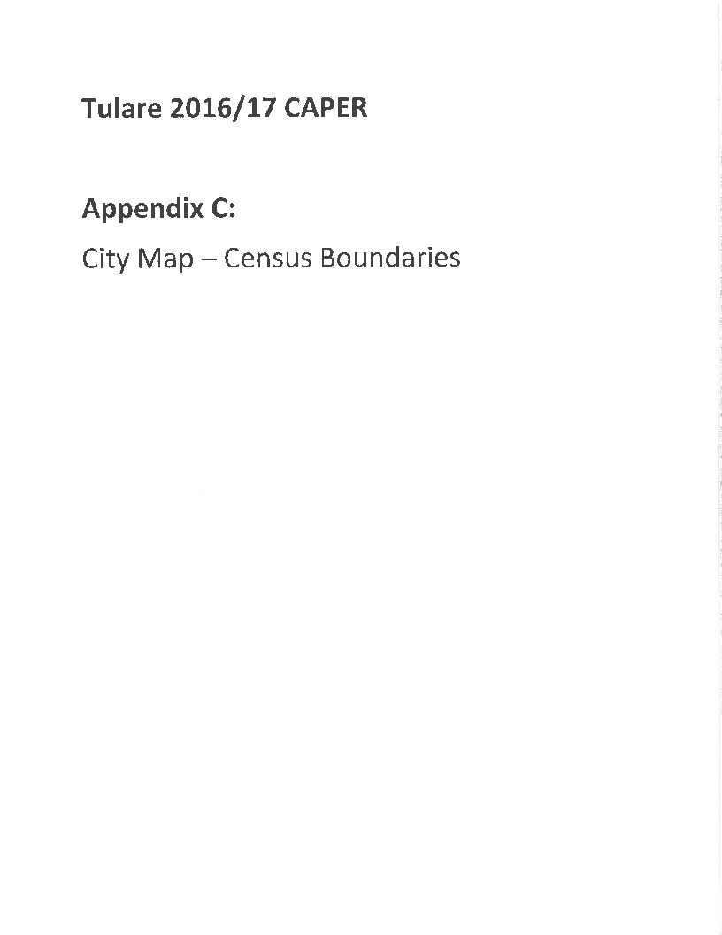

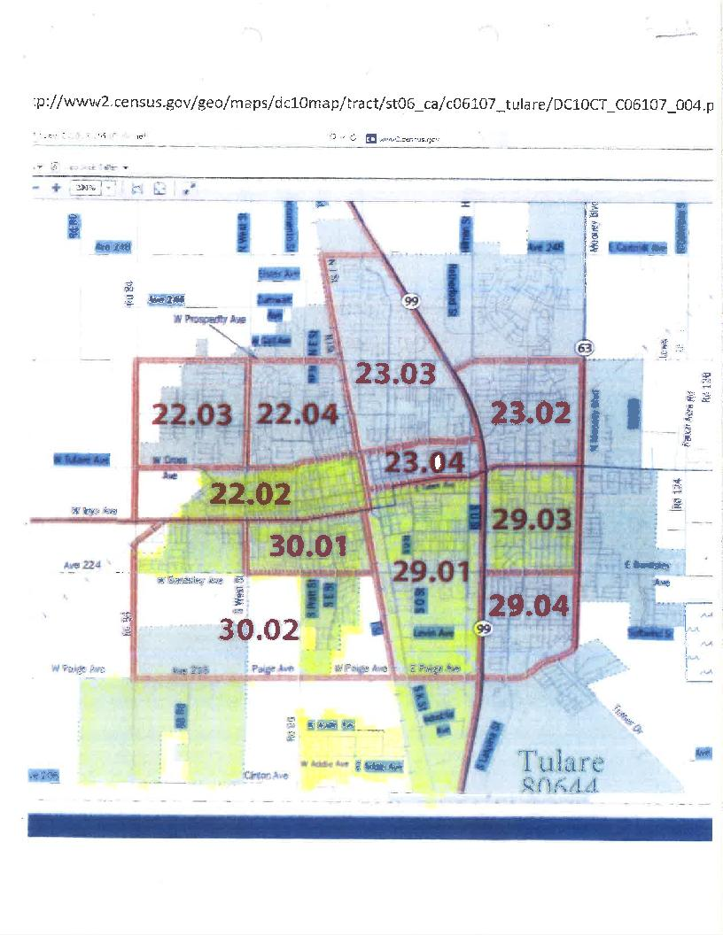

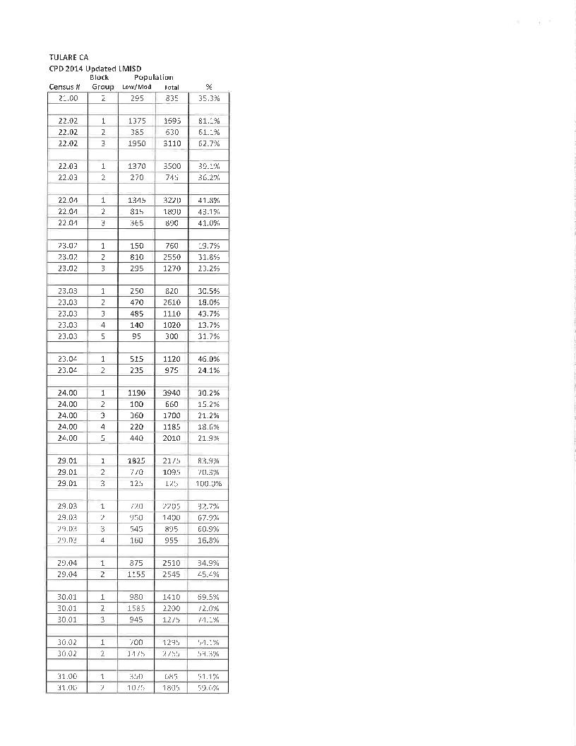

**Appendix D IDIS Reports**

